1. Design and Configuration of Mesh Topologies using Packet Tracer Mesh Topology using Hub:

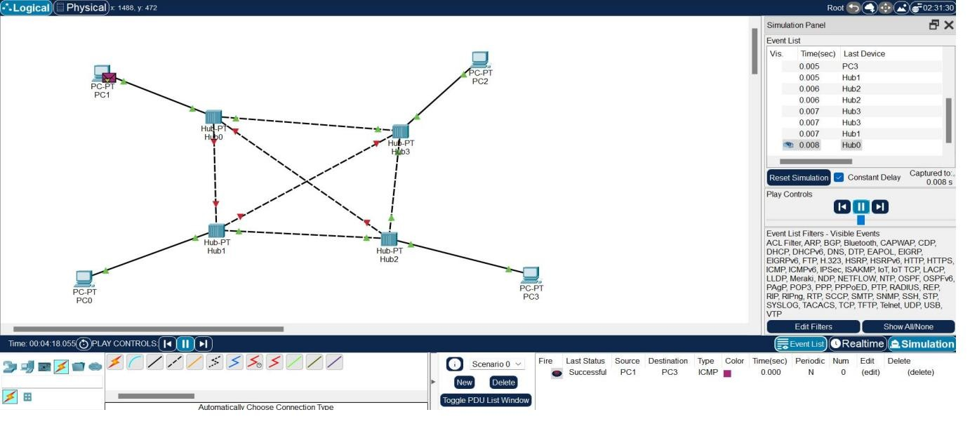

Mesh Topology using Switch:

